Rapid Procedure Example Order Set

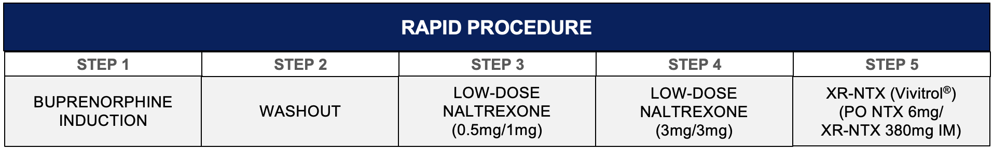

STANDING MEDICATIONS/ORDERS:
☐ clonidine 0.1 or 0.2mg po every 4 hours for opioid withdrawal symptoms, hold for sBP<90 or HR<60
☐ clonazepam 1mg po every 6 hours (MDD=4mg) for anxiety/restlessness, hold for oversedation
☐ prochlorperazine 10mg qd for nausea/vomiting
☐ trazodone 100mg po qhs for insomnia
☐ nicotine patch (7mg/14mg/21mg) topically daily
☐ oral electrolyte solution (Gatorade) 8 ounces po q4h

PRN MEDICATIONS
☐ prochlorperazine 10 mg q8h PRN for nausea/vomiting
☐ zolpidem 10mg qhs for insomnia (alternative sleep agents: mirtazapine 7.5mg q24h, diphenhydramine 50mg q24h)
☐ nicotine gum or lozenge 4mg po every 1h PRN for nicotine cravings
☐ aluminum hydroxide/magnesium hydroxide (Maalox) 30 ml q4h PRN for dyspepsia
☐ loperamide 4mg q24h PRN for diarrhea
☐ ibuprofen 600 mg q8h PRN for muscle aches and/or pain (maximum daily dosing=3200mg)
☐ acetaminophen 650mg q4h PRN for HA or mild pain (maximum daily dosing=4gm)

SWIFT PROTOCOL STEPS (to be reviewed and ordered by physician)
STEP 1: buprenorphine induction
☐ confirm active orders for standing adjunctive medications as listed above (i.e., clonidine, clonazepam, prochlorperazine, …)
☐ buprenorphine 2mg x1 if COWS ≥ 8
☐ PRN buprenorphine 2mg q1h if COWS ≥ 7 (max daily dosing=10mg for SWIFT protocol)

STEP 2: washout (no opioid agonists given for 24h)
☐ confirm active orders for standing adjunctive medications as listed above and monitor for any adverse effects

STEP 3: low-dose naltrexone titration*
☐ confirm active orders for standing adjunctive medications as listed above
☐ 1000: naltrexone 0.5mg x1 if COWS ≤ 5
☐ 1400: naltrexone 1mg x1 if COWS does not increase 3+ from last assessment

STEP 4: low-dose naltrexone titration
☐ confirm active orders for standing adjunctive medications as listed above
☐ 1000: naltrexone 3mg x1 if COWS ≤ 5
☐ 1400: naltrexone 3mg x1 if COWS does not increase 3+ from last assessment
**IF patient is requesting to leave this day, then consider administration of Vivitrol 380mg IM if both naltrexone 3mg doses tolerated and COWS ≤ 5.

STEP 5: low-dose naltrexone titration and Vivitrol administration
☐ confirm active orders for standing adjunctive medications as listed above
☐ 1000: naltrexone 6mg x1 if COWS ≤ 5
☐ 1400: Vivitrol 380mg IM x1 if COWS does not increase 3+ from last assessment

*Low-dose naltrexone dosing follows schedule with adjunctive medications being administered at 9AM.

